CSE483 COMPUTER VISION

NASA Mars Sample & Return Rover

Under the supervision of:
Dr. Mahmoud Khalil
Eng. Mahmoud Selim

TEAM 18
Salma Mohamed Saleh 19P5976
Haneen Mohamed Omar 20P7787
Maryam Muhammed Abuelmagd 19P7985
Roaa Ayman Hassan 19P6529
Hana Mahmoud Ibrahim 19p8835

DRIVE_ROVER FILE :

- stuck time , rock time were added in this file to record the moment the rover got stuck and the moment the rover started to go near the rock respectively , these variables will be used later on in the decision file to check for stuck time to decide what to do next
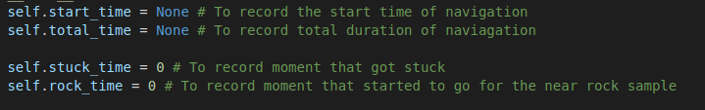
-self.samples_angles , self.samples_dists added in this file to represent angles and distance of rock sample pixels to be used to get polar coordinates of rocks in perception file to be used later on in descision file to control the steering of rover
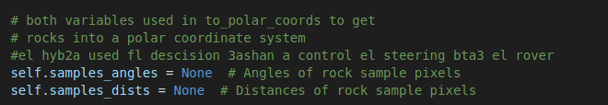

-in start up code we noticed that the rover actually needs to initiate stopping by a threshold bigger than 50 so it’s changed to100 to allow for more space to break as we also increased its speed

also the speed was very slow so we increased it to 3 instead of 2
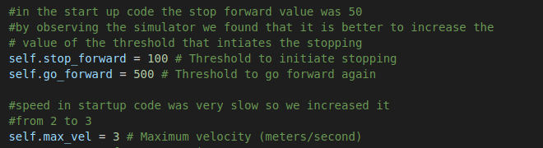

- we made rover.mode as a stack and added other modes to it like “rock “ and “stuck “, explained later on in the decision file

DECISION FILE :
decision_step function
-in this file we use the perception data to move the rover around the terrain
- our main aim is to cover most of terrain in least amount of time , allocate rocks and try not to hit obstacles as much as we could
- to reach that aim we decided to follow a wall following approach : the rover keeps steering while keeping constant distance to the walls at all times staying next to left wall in particular .
- to steer the rover we use the mean angle of the navigable points
- 10 sec so that we’re out of the starting point then we will implement the wall following behavior , we will add a positive offset to the mean angle but this unfortunately resulted in turning the rover too much and hitting the obstacles so we adjusted the offset by the standard deviation of the angles
- through trail and error we chose to scale the standard deviation by 0.8

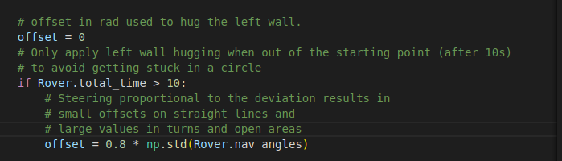

-First off, we check if there’s visible navigable data to take actions on by checking if the nav_angles is not equal to none meaning there’s navigable space detected

then we check the current mode of the Rover , as mentioned before Rover.mode is represented as a stack containing 3 different modes :
- forward
- stuck
- stop
according to each mode we will decide what to do with the rover

1. Forward mode:we will check if

- No rock in sight and there’s space to navigate in : by checking if the length of the navigable angles is more than the threshold required to initiate stopping
then check the rover’s velocity ,if :
velocity <= 0.1 : throttle=0, brake is set and rover’s mode=”stuck”, push this mode in
stack
velocity < maximum velocity : set the throttle , accelerate the rover’s speed
other than that follow the wall following approach by setting the steering value of rover
to the mean of nav_angles + offset but by clipping this value by using numpy.clip
function that will limit the steering value to 15 and -15

- No space to navigate in : by checking if the length of the navigable angles is less than the threshold required to initiate stopping or if the rover’s velocity <=0

Action :
throttle=0 , set the brake , steer=0 , Rover’s mode = “stop”, append this mode in stack

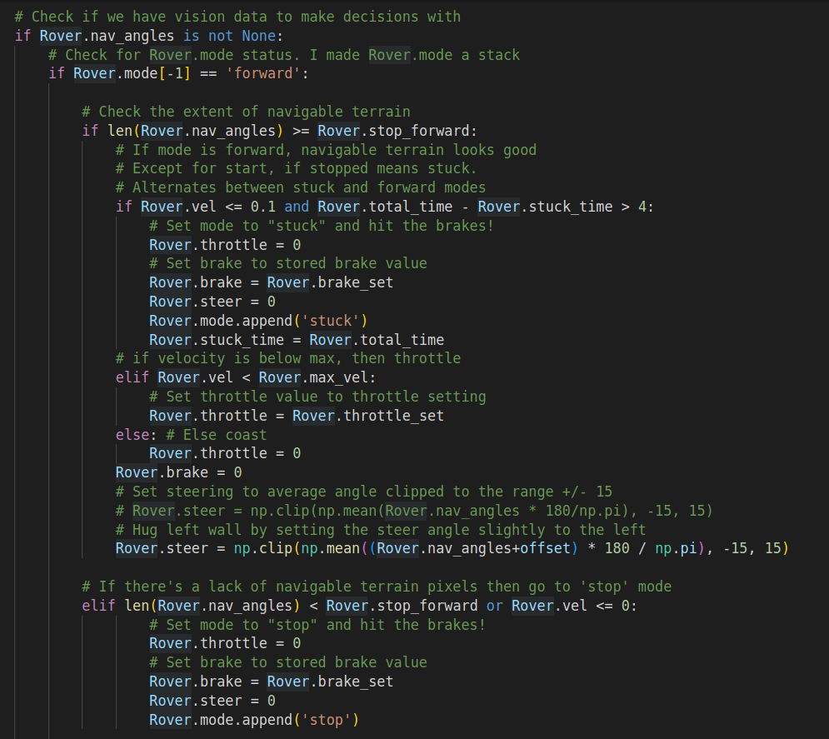

2. Stuck mode :we will check if the rover stayed in stuck state for 1 second or more
- it stayed in stuck state ore than 1 second : by subtracting the stuck time from total time and checking if it’s bigger than 1

Action : set the throttle value , brake=0 , calculate steering angle and most importantly
return to previous mode by popping the mode stack
- else :
Action :
throttle = 0 , brake=0 , steering angle :-15 , -15 is set as steering should be to the right as were hugging the left wall
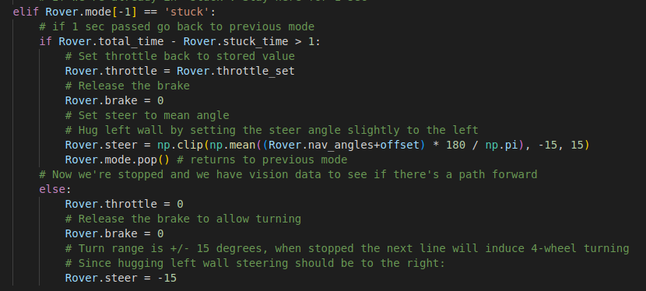

4. Stop mode :
- We’re in the stop mode already so first off we will check the rover’s velocity
- if velocity >0.2 : the rover is moving but we’re in stop mode
Action : throttle=0, set the brake , steer =0
- velocity < 0.2 : we’re not moving then according to the space detected to navigate in we will decide what to do

1. if detected navigable space is less than the threshold to go forward again :
Action : throttle=0, brake=0, and since we’re following the wall following approach we will steer to the right steer=-15
2. if detected navigable space is more than the threshold to go forward again :
Action : throttle is set , brake=0, setting the offset to 12 to get the steering angle then return to previous state as there’s a lot of space to navigate , so get out of stop mode .

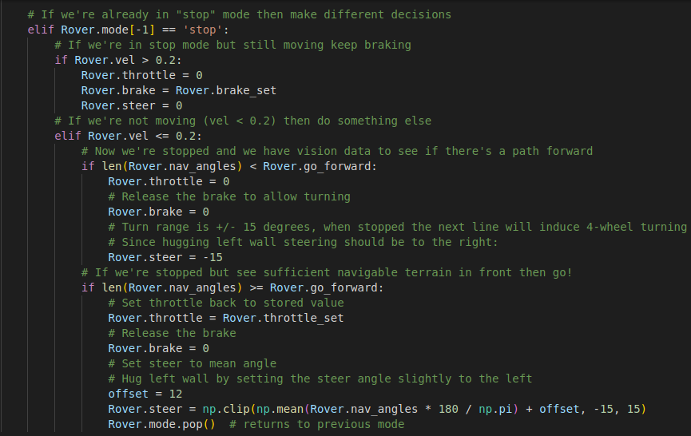

PERCEPTION FILE :
perception_step function

- by trial and error we found that the best size for grid for 1m square is 10 pixels so we identified dst_size=5
-offset=6
-here our main aim is to get the bird eye view like we did in the walkthrough by using dist_size and offset
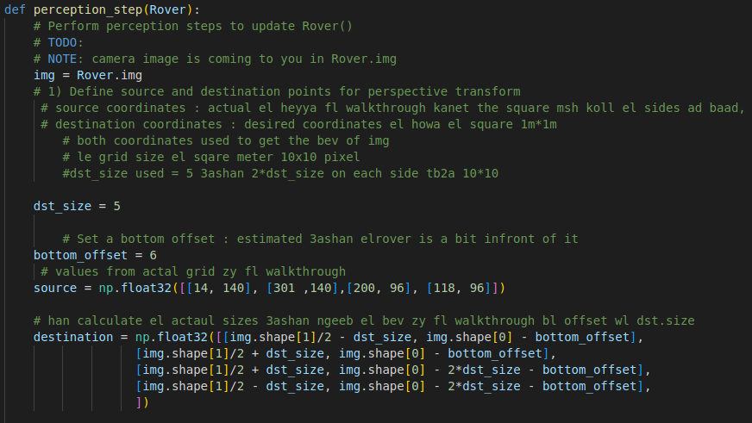

Here our main aim is to identify rocks , obstacles and terrain by color threshold
- color_thresh : creates an array same size as image but all its values = zero then checks the threshold of each channel and gives “ true” as a value in abovethresh array then for each true value it gives it 1 then it returns binary image

0
0

here it takes the warped image , set it to 1 at navigable areas and 0 at obstacles
- rock is identified as it falls under the hue value of 24 o by taking 10 pixels below and above we’re able to get the lower and upper bounds of each rock
-using cvtColor we convert the RGB to HSV for better image processing as it segments objects based on color
- then we detect objects by inRange functions based on HSV values

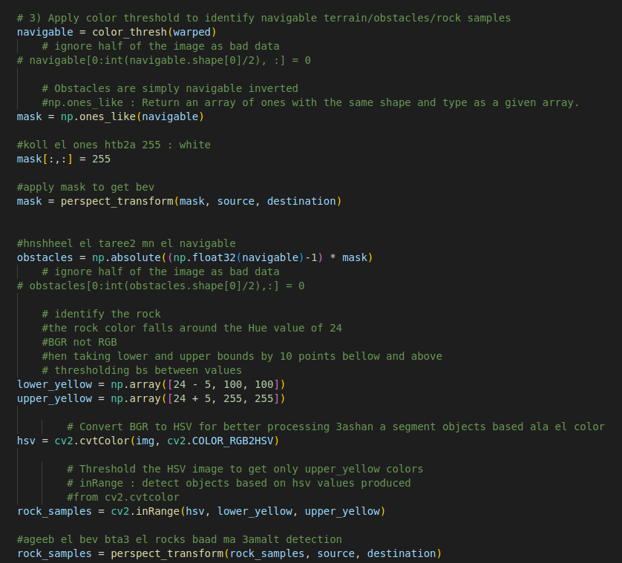
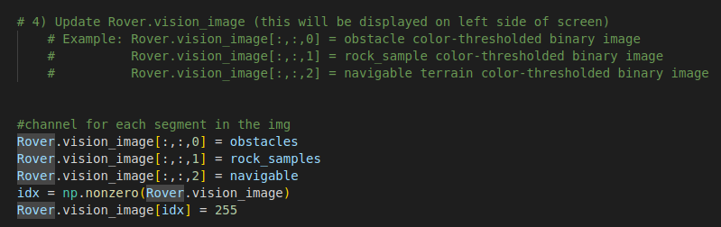
On the left side of the screen each of the obstacles , terrain and rocks will be given a channel each

- we use the function rover_coords to convert the map image pixel into rover-centric coords to be able to map it on to the world map.
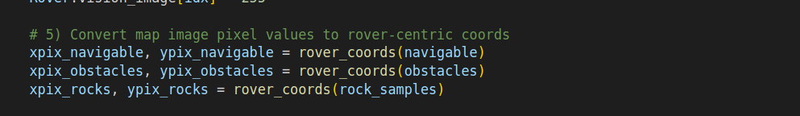
- since in the now rover-centricimage coords, each 10x10 pixels qualify for 1 squared metre but in the world map it is 1x1 pixel for every squared meter, so we need to scale it down by 10 to map it onto the world map. Then we use the pix_to_world function to conver the rover-centric pixel values to world coordinates.

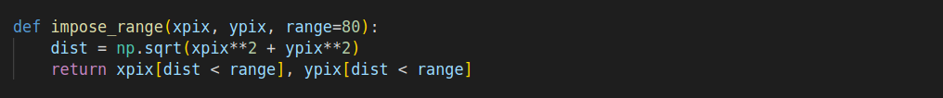
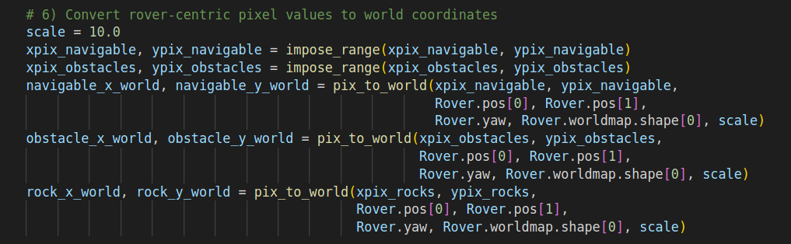

- Continuously update the rover worldmap

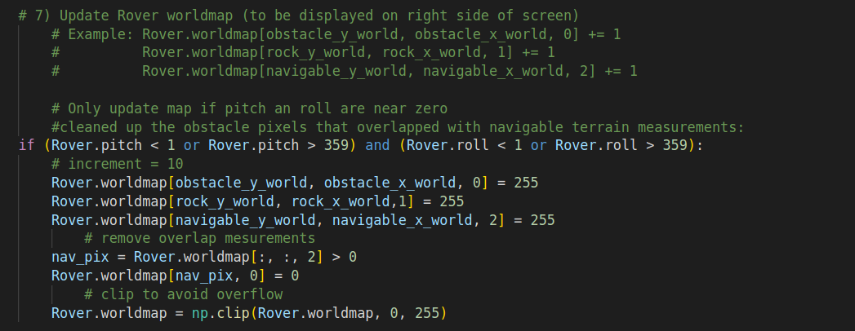

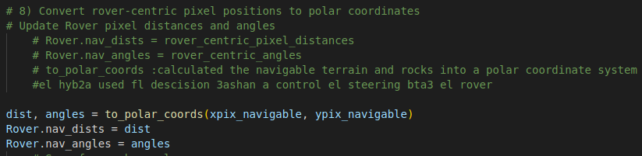
- here we get the polar coordinates for the navigable terrain to be used later on in the decision file to control the steering of the rover

